Question 1: Leo Mosquera

SELECT first_name, last_name, email

FROM customer

WHERE email REGEXP '[@gmail.com](http://@gmail.com)';

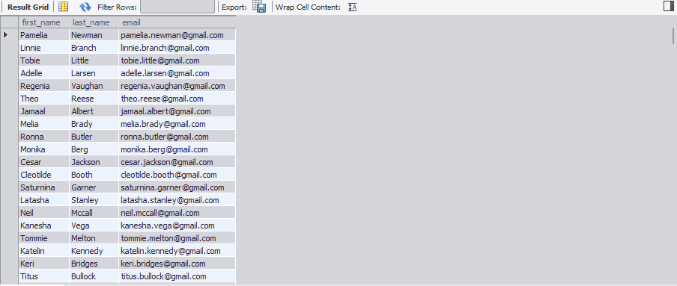

Question 2: David Burguete

SELECT product_name AS Bike_Name,

list_price AS Original_Price,

ROUND(list_price * 0.8, 2) AS Sales_Price

FROM product

WHERE brand_id = 2;

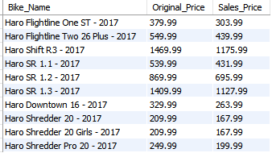

Question 3: Cody Karl

SELECT cust_order_id,

order_date

FROM cust_order

WHERE store_id = 1 AND staff_id != 2;

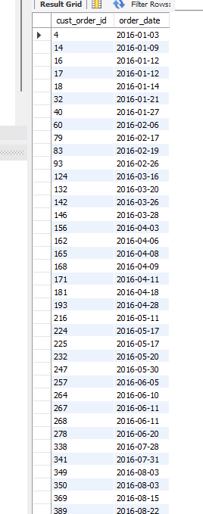

Question 4: Leo, David, Cody

SELECT cust_order.cust_order_id,  
   cust_order.order_date,  
 product.product_name  
 FROM cust_order, product  
 WHERE (product.product_name REGEXP "Women's"   
 OR product.product_name REGEXP "Frame")  
 AND MONTH(cust_order.order_date) = 02  
 AND YEAR(cust_order.order_date) = 2017;

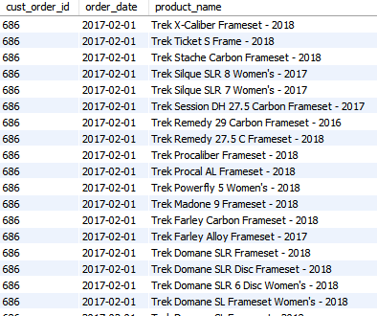

Question 5: Leo, David, Cody

SELECT   
 product_name  
 FROM   
 product  
 WHERE   
 LEFT(product_name, 1) BETWEEN 'A' AND 'H'  
 AND list_price >= 299.99  
 ORDER BY   
 product_name;

